Linux Command Line Tasks

# 1. Creating and Renaming Files/Directories

Commands:  
mkdir test_dir  
touch test_dir/example.txt  
mv test_dir/example.txt test_dir/renamed_example.txt  
  
Explanation:  
- 'mkdir' creates a new directory.  
- 'touch' creates an empty file.  
- 'mv' moves or renames files.

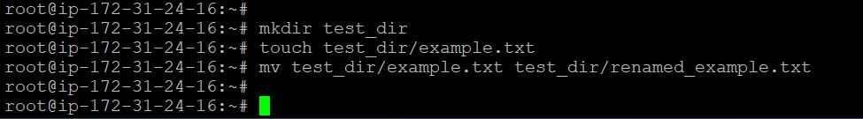

# 2. Viewing File Contents

Commands:  
cat /etc/passwd  
head -n 5 /etc/passwd  
tail -n 5 /etc/passwd  
  
Explanation:  
- 'cat' prints the contents of a file.  
- 'head -n 5' shows the first 5 lines.  
- 'tail -n 5' shows the last 5 lines.

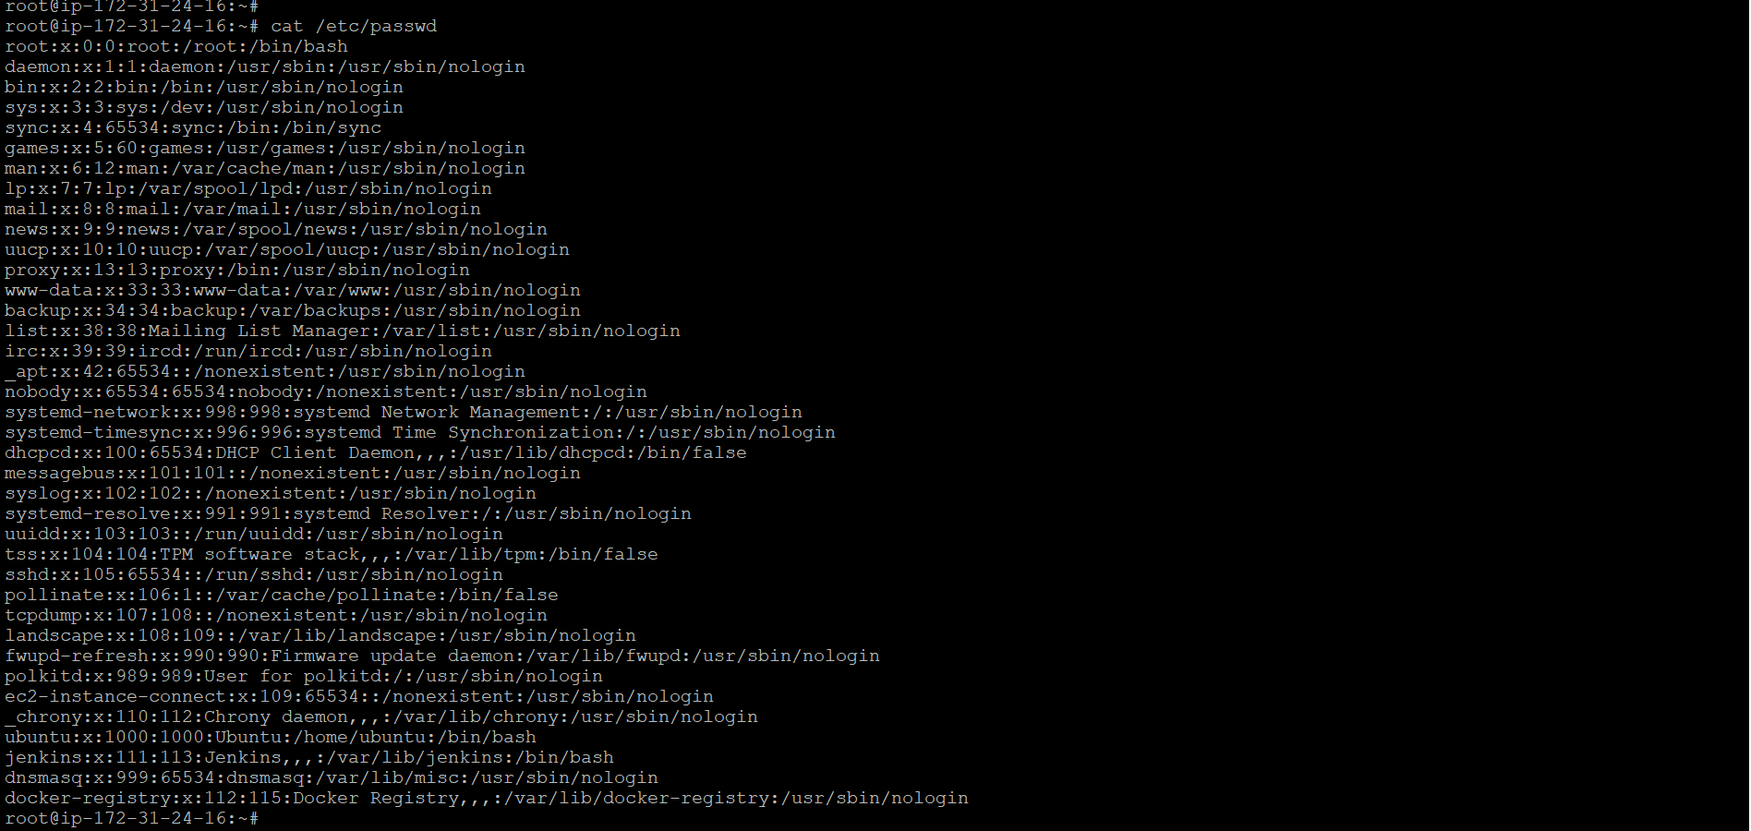

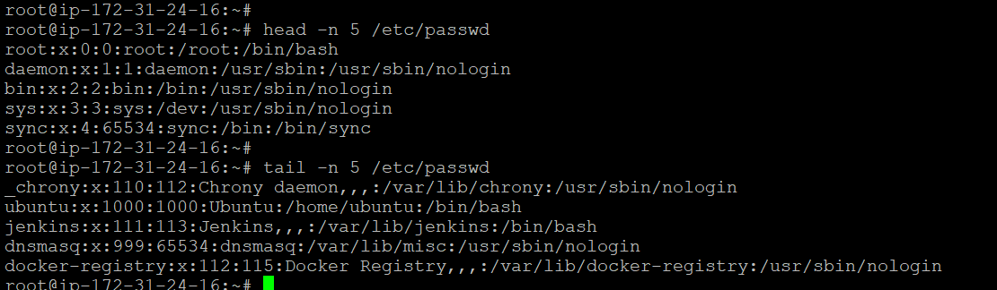

# 3. Searching for Patterns

Command:  
grep "root" /etc/passwd  
  
Explanation:  
- 'grep' searches text using patterns. Here, it lists all lines with the word "root".

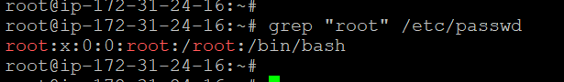

# 4. Zipping and Unzipping

Commands:  
zip -r test_dir.zip test_dir  
unzip test_dir.zip -d unzipped_dir  
  
Explanation:  
- 'zip -r' compresses directories recursively.  
- 'unzip -d' extracts contents into the specified directory.

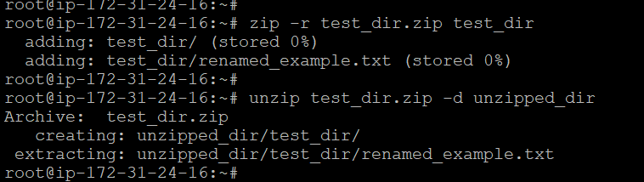

# 5. Downloading Files

Command:  
wget https://example.com/sample.txt  
  
Explanation:  
- 'wget' downloads files from the web.

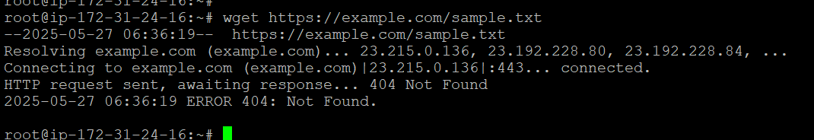

# 6. Changing Permissions

Commands:  
touch secure.txt  
chmod 444 secure.txt  
  
Explanation:  
- 'chmod 444' sets read-only permissions (4 for owner, group, and others).

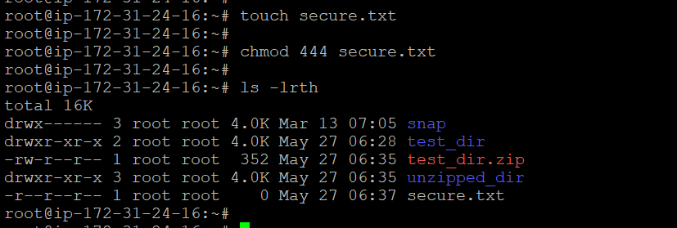

# 7. Working with Environment Variables

Command:  
export MY_VAR="Hello, Linux!"  
  
Explanation:  
- 'export' sets environment variables that are available to child processes.

